**Predicting personality trait from the power spectra of resting state EEG**

YEVHENIIA KRYVENKO, JANNO PETERSON, University of Tartu, Estonia

**Abstract:** The main goal of this project is to detect whether it is possible to figure out the expression of personality traits based on EEG recording in resting state applying dimensionality reduction techniques or machine learning algorithms (binary classification). EEG data was collected from a large sample of subjects (n=289) who had answered questionnaires measuring personality trait scores of the 5 dimensions of the Big Five Model. Results show that the five personality traits could not be accurately predicted from power spectra data.

# **INTRODUCTION**

There exists a lot of models to describe personal traits in psychology. One of them is general taxonomy of [personality traits](https://www.sciencedirect.com/topics/neuroscience/personality-traits), known as the “Big Five” which consist of such traits: openness to experience, conscientiousness, agreeableness, [neuroticism](https://www.sciencedirect.com/topics/neuroscience/neuroticism) and extraversion. Such tests are useful in many spheres (for example organization communication) to detect how a person carries themselves in the workplace and community.

As usual, psychologists use a special questionnaire to detect collections of aspects or facets which are related to each other but are not identical.

Although personality means set of individual characteristics which could be measured by special questionnaire, brain activity with some prescription produce individual neuron activity which could be able to detect such information.

The human brain’s oscillations accompanies important brain functions and could be considered in several types to create functional brain imaging modality: the [functional magnetic resonance imaging](https://www.sciencedirect.com/topics/neuroscience/functional-magnetic-resonance-imaging) (fMRI), [positron emission tomography](https://www.sciencedirect.com/topics/neuroscience/positron-emission-tomography) (PET) and [electroencephalography](https://www.sciencedirect.com/topics/neuroscience/electroencephalography) (EEG).

During the research problem overview there have been found two contradicting positions.

Scientific literature has been published, describing the potential correlation between psychometric measures and brain oscillations [1].

Meanwhile, others have claimed it is impossible to detect information about personality traits from EEG recording [2].

**The goal of the project** is to generate a model which will be able to accurately predict a person’s personality traits (from FFM) based on their resting state EEG data.

# **BACKGROUND**

**Electroencephalogram (EEG) signal**

EEG is a procedure to evaluate the electrical activity in the brain by using several electrodes that are attached to patient’s scalp. As brain cells communicate with each other through electrical impulses, the electrodes transfer this information from the brain to a machine that measures and records the data [3]. The EEG approach could complement the findings due to its ability to measure the brain electrical activity directly and has an excellent temporal resolution [4].

The electrical impulses in an EEG recording look like wavy lines with peaks and valleys. However, EEG representation in the time domain is a combination of waves of variety amplitude number and noise that are difficult to distinguish and interpret. To solve this problem it would be suitable to apply Fourier Transform analysis.

Since we want to study not the dynamics of the signal reaction to a certain stimulus, but the temperament (i.e. constantly present factor), we do not need to analyze EEG in the time scale and it would be more convenient and practical to analyze the transformed data after a linear Fourier transformation.

**Fast Fourier Transform (FFT) analysis**

FFT transforms a signal from the time domain into the frequency domain. Using this approach lengthy and noisy EEG recording can be conveniently plotted in a frequency [power-spectrum](https://en.wikipedia.org/wiki/Spectral_density#Power_spectral_density). By adding all the sinusoids up after FFT, the original signal can be restored, so no information is lost.

The continuous Fourier Transform of a function x(t) is defined as :

where are complex exponentials and w is the angular frequency related to the linear frequency f by w = 2·pi·f [5].

The formula X(w) quantifies the amount of activity at each frequency w of the original signal.

# **METHODS**

# **Data description**

Data folder consists of 2 datasets:

1. Power spectra of the resting state EEG data: 2 matrices (289 participants by 32 electrodes by 183 frequencies)

Data was collected firstly in 5 experiments where the resting state signal was recorded in two contiguous sections: one with eyes open and the other with eyes closed. Each section lasted either for 1 minute (in one experiment with 84 participants) or 2 minutes (in four experiments with 94 participants). In the remaining 7 experiments (131 participants) 3 separate 1-minute measurements with eyes open and eyes closed were interleaved resulting in 3 minutes in total for both the eyes open and eyes closed conditions [1].

1. Questionnaire matrix: matrix (289 participants * 5 traits) contains “0” or “1” meaning this trait is highly expressed or lowly expressed respectively.

# **Data preprocessing**

During the working process the continuous data manipulations were performed. First of all, a huge dataset with temporary data was reduced to dataset with frequencies, but which still displays all information about EEG (this part was done by applying FFT by authors [1]). The next step is to reduce the number of electrodes. From 32 dimensions (electrodes) we expect to obtain only several dimensions by averaging all signals or aggregation in a special way.

For preprocessing the data, we used three different approaches. The first approach was to average the power spectra values of 32 channels for each frequency, resulting in a dataset with 289 rows and 183 features (Figure 1.a shows).

For the second approach, we used the results obtained from the first approach and aggregated the frequencies based on the type of brain waves (Figure 1.b shows) by finding the average power spectra value for frequencies into 5 ranges:

* gamma - from 30 to 90 Hz
* betta - from 12 to 30 Hz
* alpha - from 8 to 12 Hz
* theta - from 4 to 8 Hz
* delta - from 0.5 to 4 Hz

The third approach was to flatten the data of 32 channels and 183 frequencies for each of the 289 subjects, resulting in a dataset with 289 rows and 5856 features.

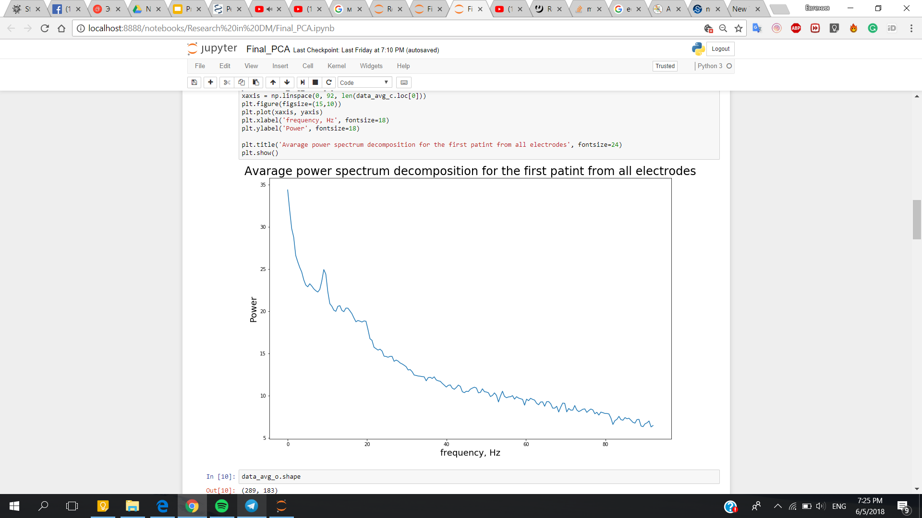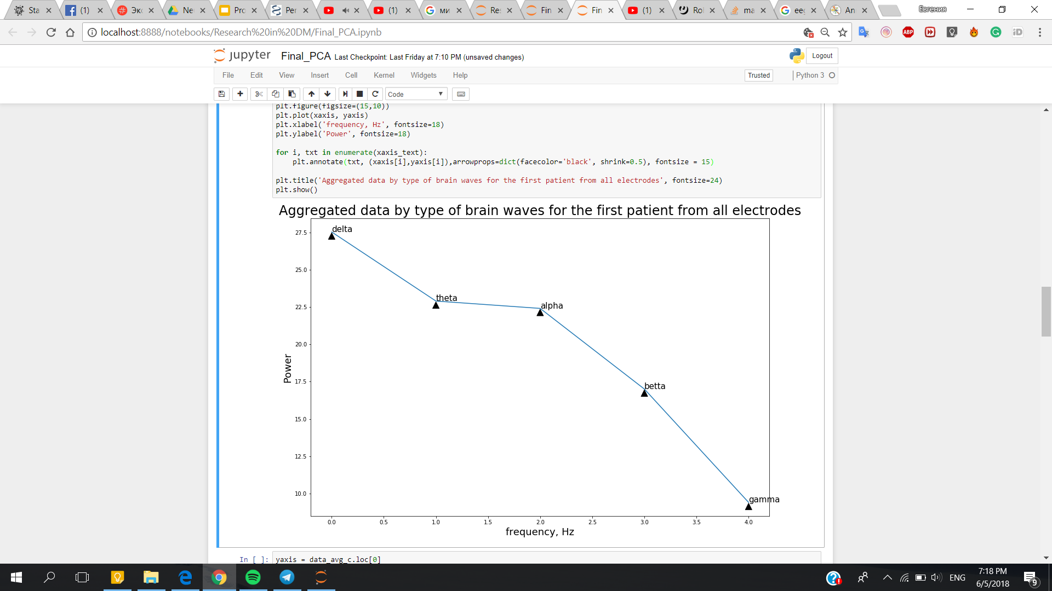

*Fig. 1. Power spectra of EEG visualization for the random chosen participant with eyes closed condition a) data averaged from all electrode, b)aggregated data by type of brain waves*

# **Dimensionality reduction**

*Principal component analysis (PCA)*

Principal component analysis (PCA) is a statistical technique used to emphasize variation and bring out strong patterns in a dataset by orthogonal transformation. The initial dataset of possibly correlated variables converts to a set of values of [linearly uncorrelated](https://en.wikipedia.org/wiki/Correlation_and_dependence) variables (principal components). It is often used to make data easy to explore and visualize.

*t-Distributed Stochastic Neighbor Embedding (t-SNE)*

t-SNE is a nonlinear technique for dimensionality reduction that is particularly well suited for the visualization of high-dimensional datasets. Specifically, it models each high-dimensional object by a two- or three-dimensional point in such a way that similar objects are modeled by nearby points and dissimilar objects are modeled by distant points with high probability [6].

We used dimensionality reduction techniques such as PCA and t-SNE for two purposes: to find out, if we could find separation between the data points after dimensionality reduction, and to reduce the number of features in all datasets from the preprocessing approaches we took, especially in the flattened data from the third approach.

The first step for separating the data was to run PCA using preprocessed data to guess if it is possible to distinguish 2 groups (Figure 2.a shows). We experimented with svd_solver parameter in case of PCA sklearn implementation and with kernel parameter in case of KernelPCA sklearn implementation.

*Fig. 2. Visualization of the PCA results based on a) the dataset obtained from the second preprocessing approach b) the dataset obtained from the second preprocessing approach and “Extraversion” trait*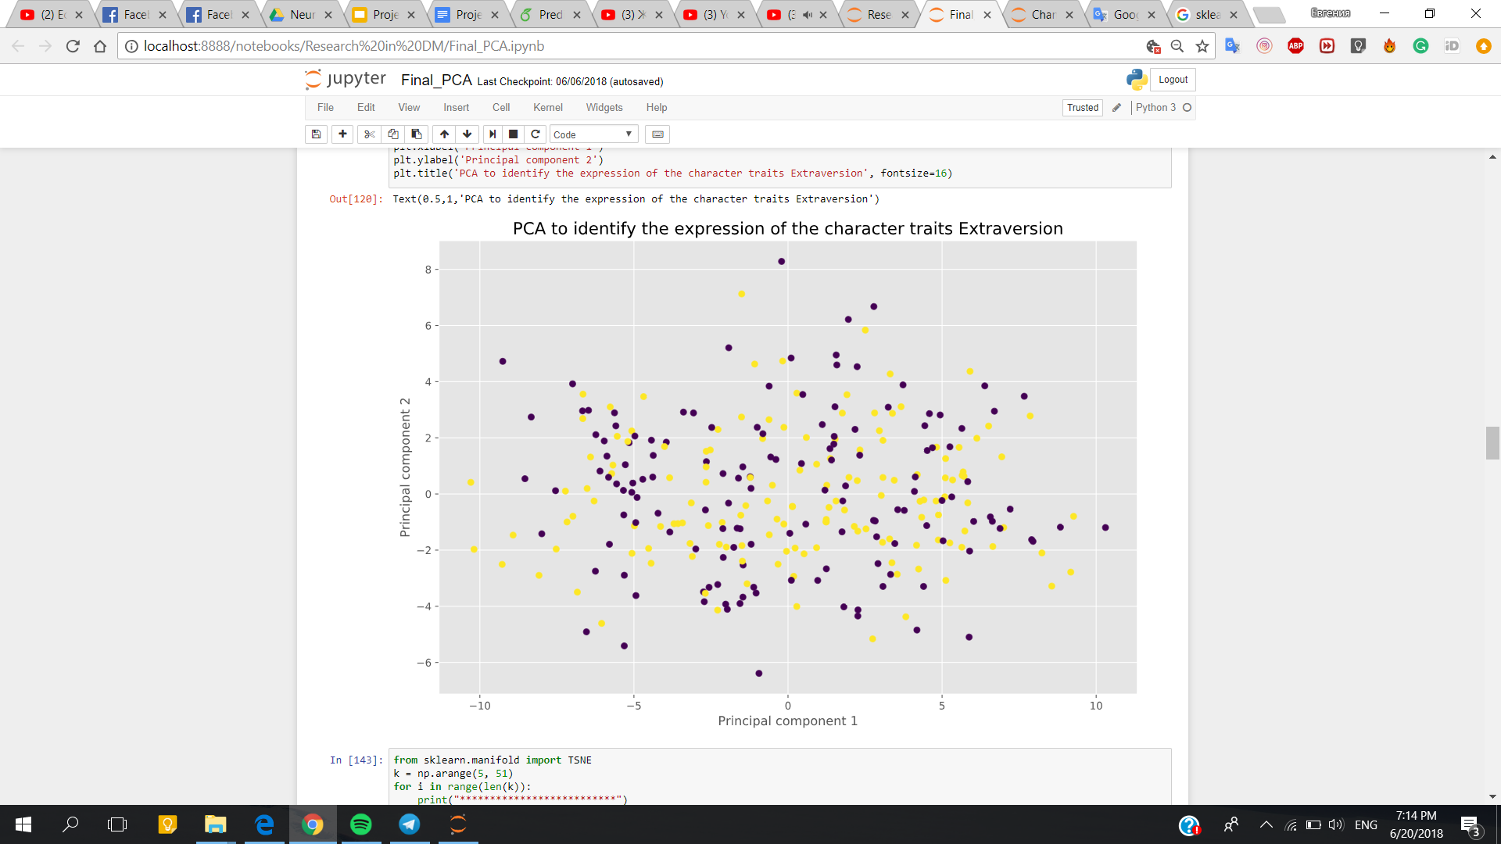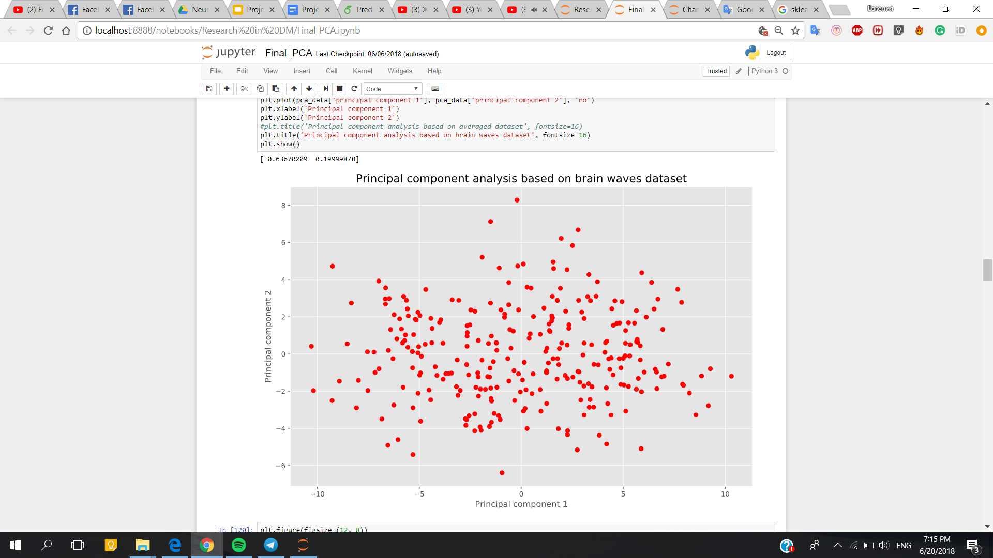

The next step is to throw in traits dataset as additional layer to visualise the distribution of chosen trait expression for all participants (Figure 2.b shows).

Dimensionality reduction was also used to reduce the number of features for binary classification. This has two benefits: it helps transform the features to represent the data better, which helps the machine learning classifiers to make better generalization on the data. Also, it helps with overall reduction of features (especially with the third preprocessing approach) and helps the classifiers perform faster.

# **Binary classification**

Since the personality trait values in our dataset were binary, we used binary classification methods to see if we could predict the expression of personality traits based on the power spectra data of the subjects.

For all preprocessing approaches, we tried k-nearest neighbors (KNN), Support vector machine (SVM) classifier, random forest classifier (all algorithm implementations were used from scikit-learn: free software machine learning library for the Python programming language [7]).

KNN classification was implemented on all preprocessed datasets and also on data that had been transformed by dimensionality reduction (by t-SNE with 2 dimensions and 3 dimensions, or by PCA with 80% variance explained). SVM was implemented on PCA-transformed data (80% variance explained), with no kernel (linear SVM) and with RBF kernel. Random forest was implemented on the same preprocessed datasets and PCA-transformed data (80% variance explained). Each model’s performance was measured by mean accuracy score on 10-fold cross-validation. Since linear SVM model’s performance was initially the best, we tried to focus on optimizing it further, by finding an optimal penalty parameter value C for each trait. For this, we used nested 10-fold cross-validation for each trait separately.

For each iteration of the 10-fold cross-validation, we fit a PCA model on 90% of the data and transformed the data (the 90% and the rest of the 10%) with that model. Using the transformed 90% of the data, we tried 10 different C values from range 1.0E-6 to 1.0E-4. For each of these values, we used 10-fold cross-validation to measure the performance of SVC classifier with the given C value. After completing the 10-fold cross-validation on a single C value, we saved the mean accuracy from the cross-validation. After getting the mean for each C value, we chose the C value, which gave the best mean accuracy. After getting the optimal C-value, we fit the original 90% of the data (from the outer cross-validation) on an SVC model with the given C value. We then predicted the personality trait expression values on the transformed 10% of the data, and found the accuracy score for it. After finishing the cross-validation, we got the mean of the found accuracies, which we used as the overall accuracy score on a single trait.

To determine whether the accuracy scores of our models were significant or not, we performed statistical hypothesis testing. For this, we used permutation tests, where we shuffled the trait labels, and then performed binary classification on the shuffled data, following the same steps as we did on the original data. The accuracy score is then saved and the process is repeated for thousands of times. As a result, we get a distribution of accuracy scores on the shuffled datasets. To get the p-value from the test, we take the accuracy score that we got from the original data, and find out, what proportion of the permutation test iterations gave a better accuracy score than that. If the proportion of these cases is smaller than 0.05, we could say with a confidence level of 95% that the original results were significant.

# **RESULTS**

We had a dataset of power spectra of 289 subjects’ EEG recordings (with 32 electrodes) with eyes open and eyes closed condition, along with binary Big Five personality values (representing either strongly or weakly expressed traits).

To find a way to predict personality trait values from the power spectra data, we used three approaches for preprocessing the data (detailed under Methods section).

After each preprocessing approach, we used dimensionality reduction techniques (PCA, t-SNE) in order to find visual separation between the personality trait values for each trait, but they did not give any clear separation of data points for any of the five personality traits. On averaged waves dataset for eye closed condition PC1 explains 78.65% of total variance and PC2 explains 11.49% of total variance. And on brain waves dataset for eye open condition PC1 explains 63.67% of total variance and PC2 explains 19.99% of total variance.

Unfortunately it is impossible to separate two groups (more or less expressed trait) for each personality trait (based on Figure 3 and 4). Moreover, in case of t-SNE analysis there were done several experiments with “perplexity” tuning (this parameter may be viewed as the number of effective nearest neighbors and responsible for data grouping) but for any value from the range [5, 50] the results are scattered and do not carry semantic information.

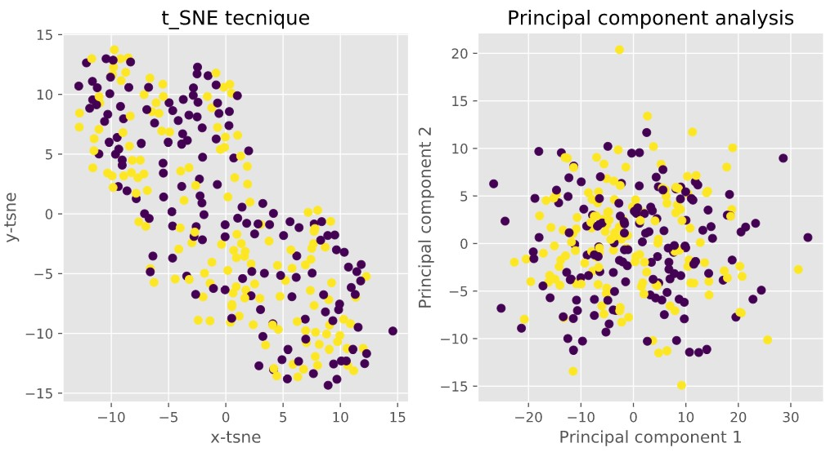

*Fig. 3. Eyes closed averaged dataset (trait = Agreeableness)*

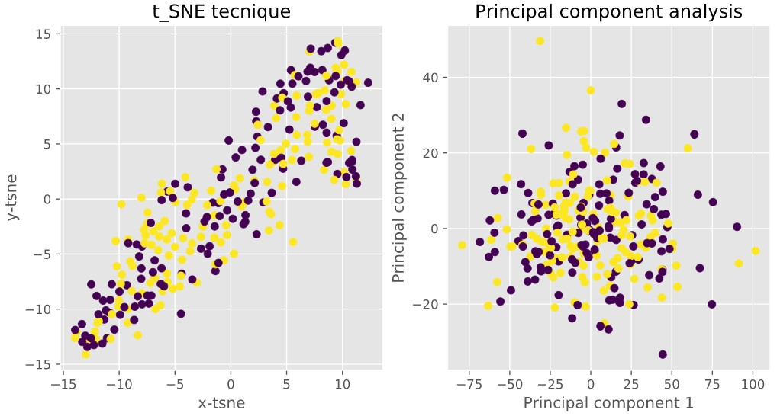

*Fig. 4. Eyes open averaged dataset (trait = Extroversion)*

We also used different binary classification methods (KNN, Random Forest, SVM) to see if we could train models on the preprocessed data to accurately predict personality trait values. From the classification methods we used, the Support Vector Machine (SVM) gave consistently the best results. In order to optimize the SVM model, we found optimal penalty parameter values (C) for each personality trait. To evaluate the models, we used k-fold cross-validation.

During binary classification for each personality trait was chosen the most suitable dataset from preprocessing step and fitted C parameter. We managed to obtain the feature importance plot for further exploration analysis where the x axis means the frequency divided by 2 and the y axis reflect the coefficient (Figure 5 shows). Such plot helps to understand what features are used by SVC model to classify each instance and in practice the square of the coefficients are used for ranking the features and decision about relevance of each one.

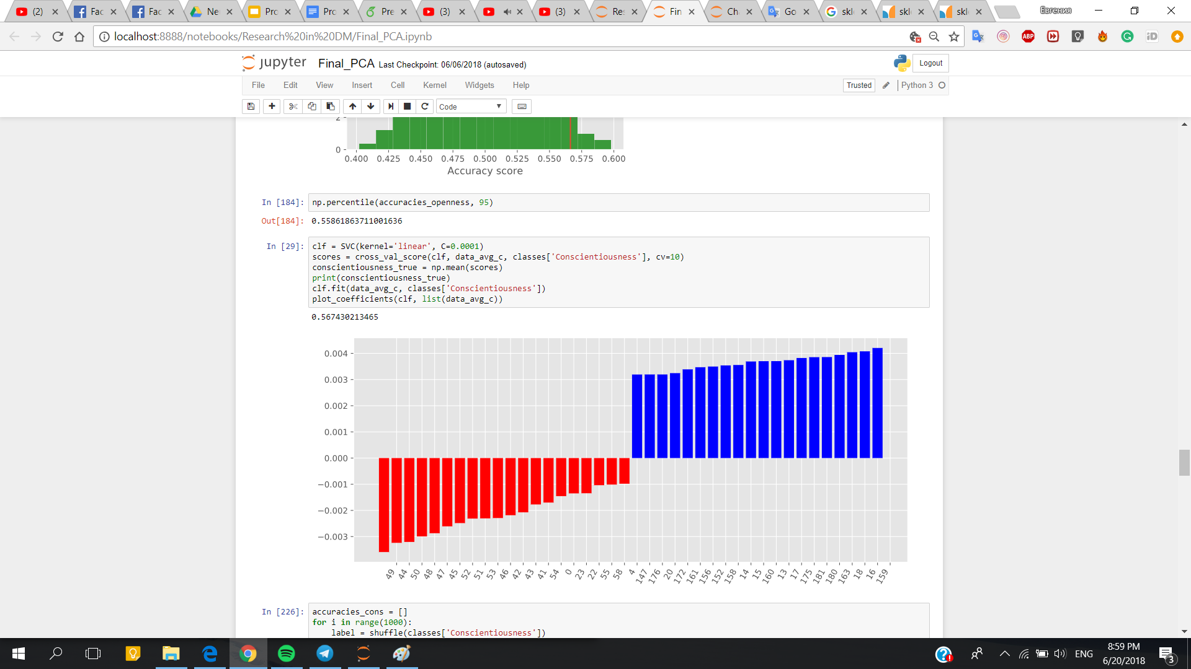

*Fig. 5. Feature importance plot during “Conscientiousness” trait classification based on eyes closed averaged dataset*

As a result, we got an accuracy score of close to 0.55 for Extraversion and accuracy scores close to 0.56 for Openness and Agreeableness. To test the significance of these results, we used permutation tests (results shown on Figures 6 and 7). For traits Openness and Agreeableness, the p-value was around 0.05. However, we should take into account the fact that we performed multiple statistical tests, which means that with each test we perform, the probability that one of them has a p-value below 0.05, goes up. As a conclusion, we can not confidently say that the results we found were significant.

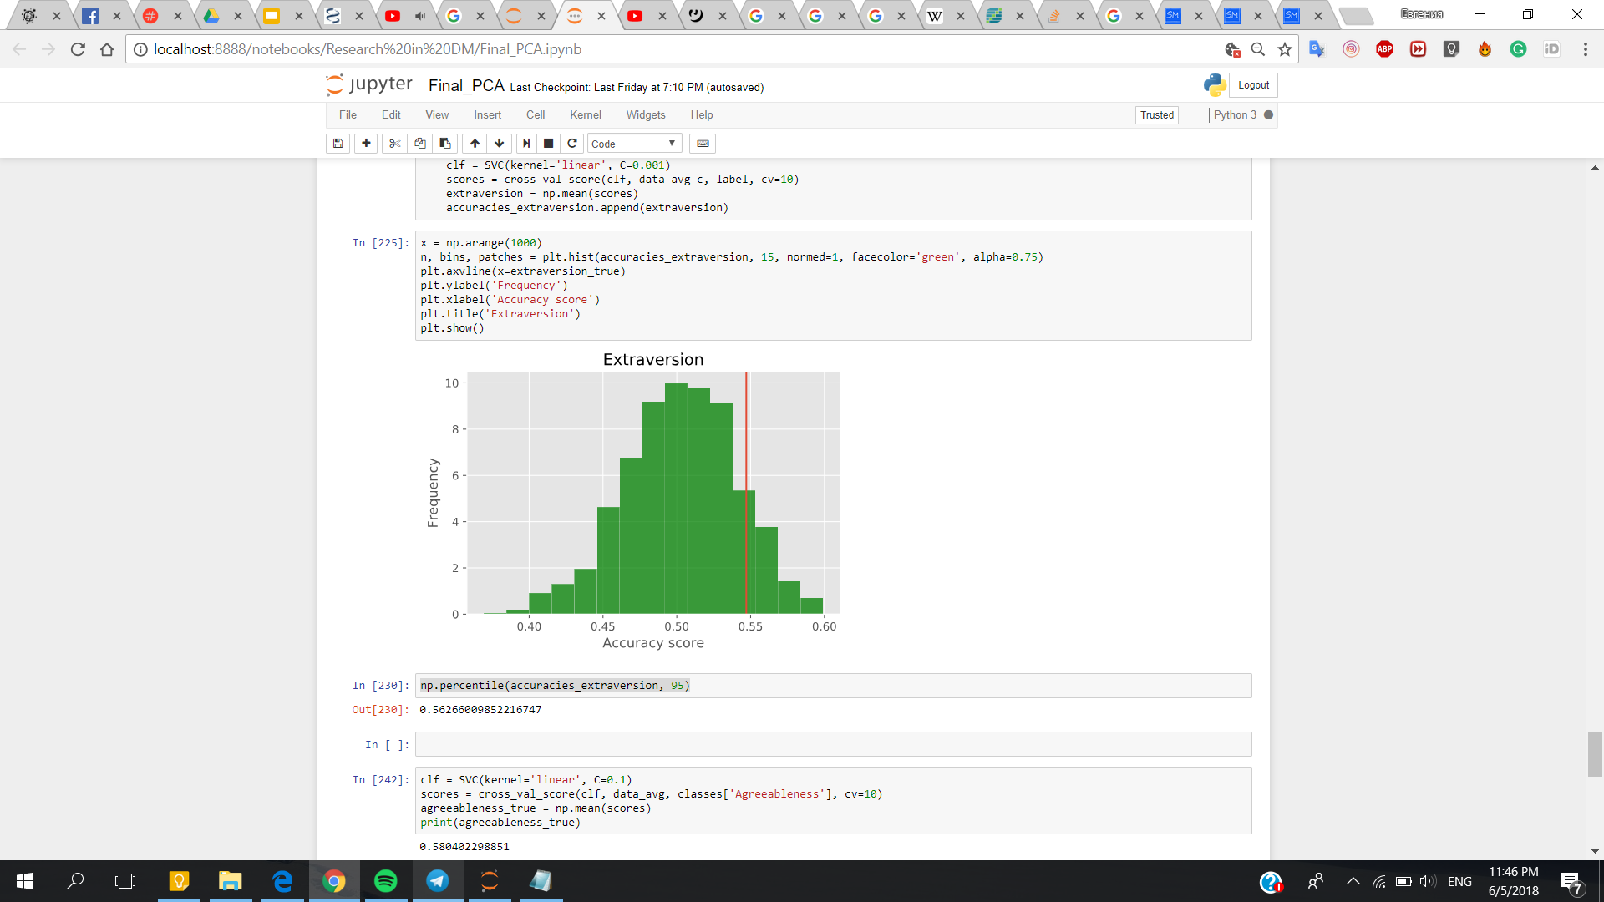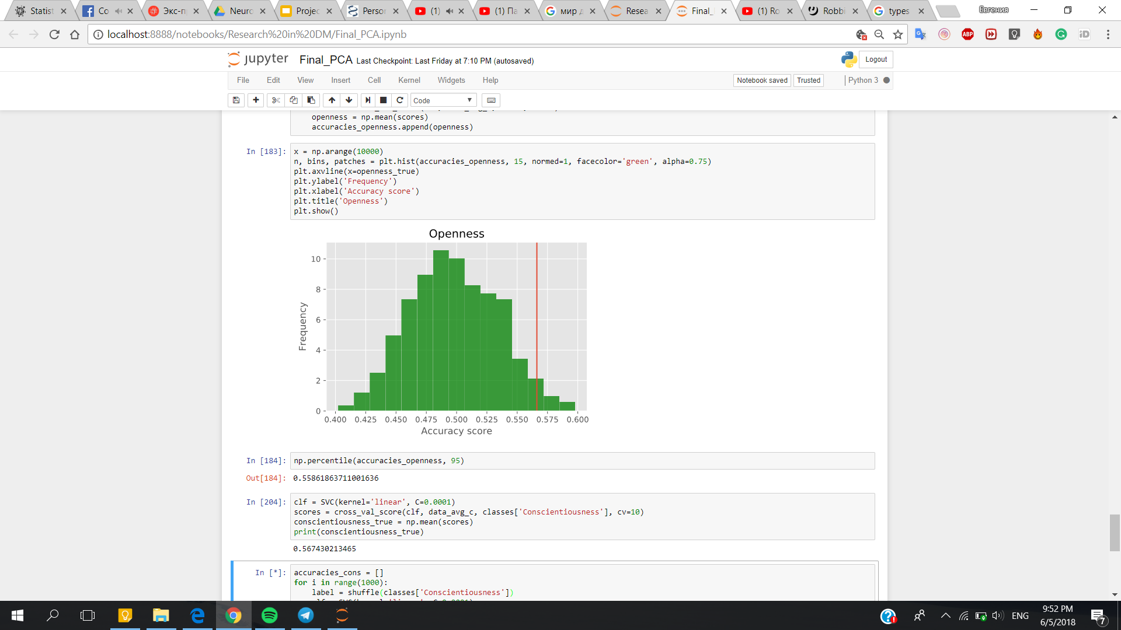

*Fig. 6. Hypothesis testing for a) Extraversion trait b) Openness trait*

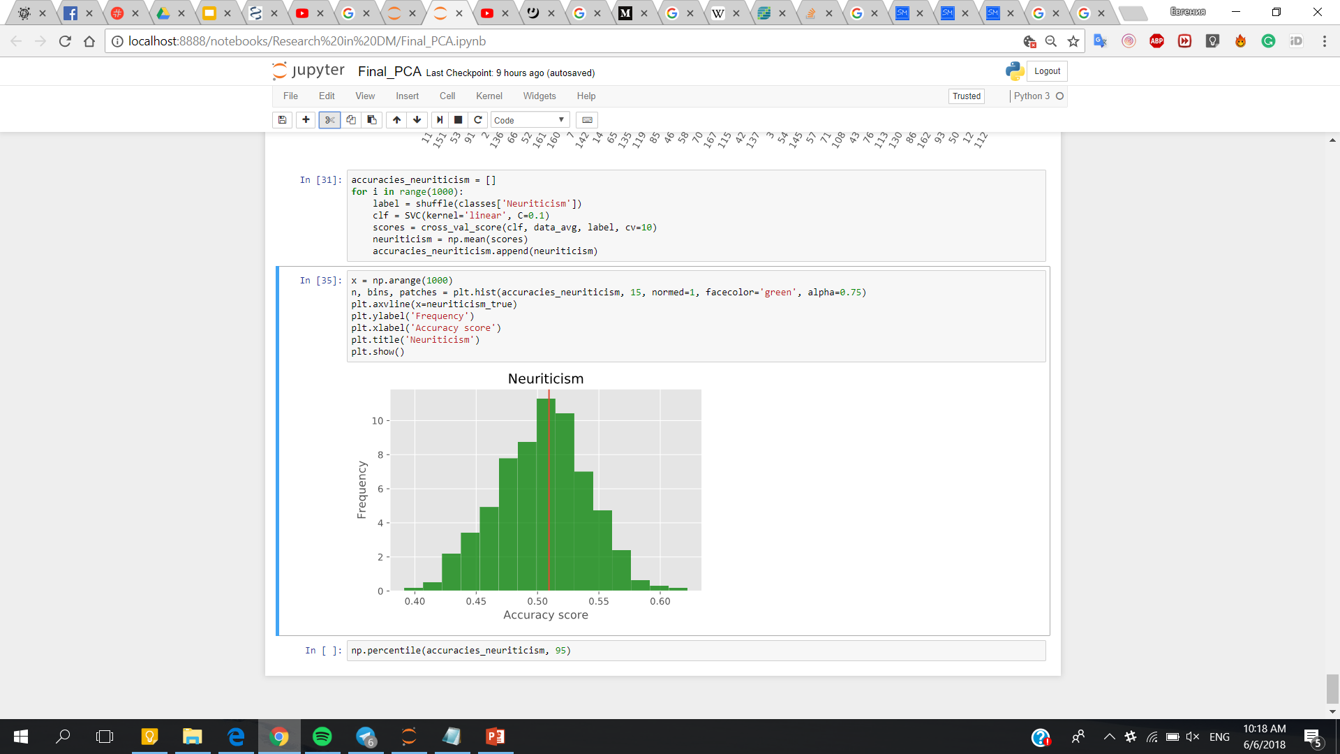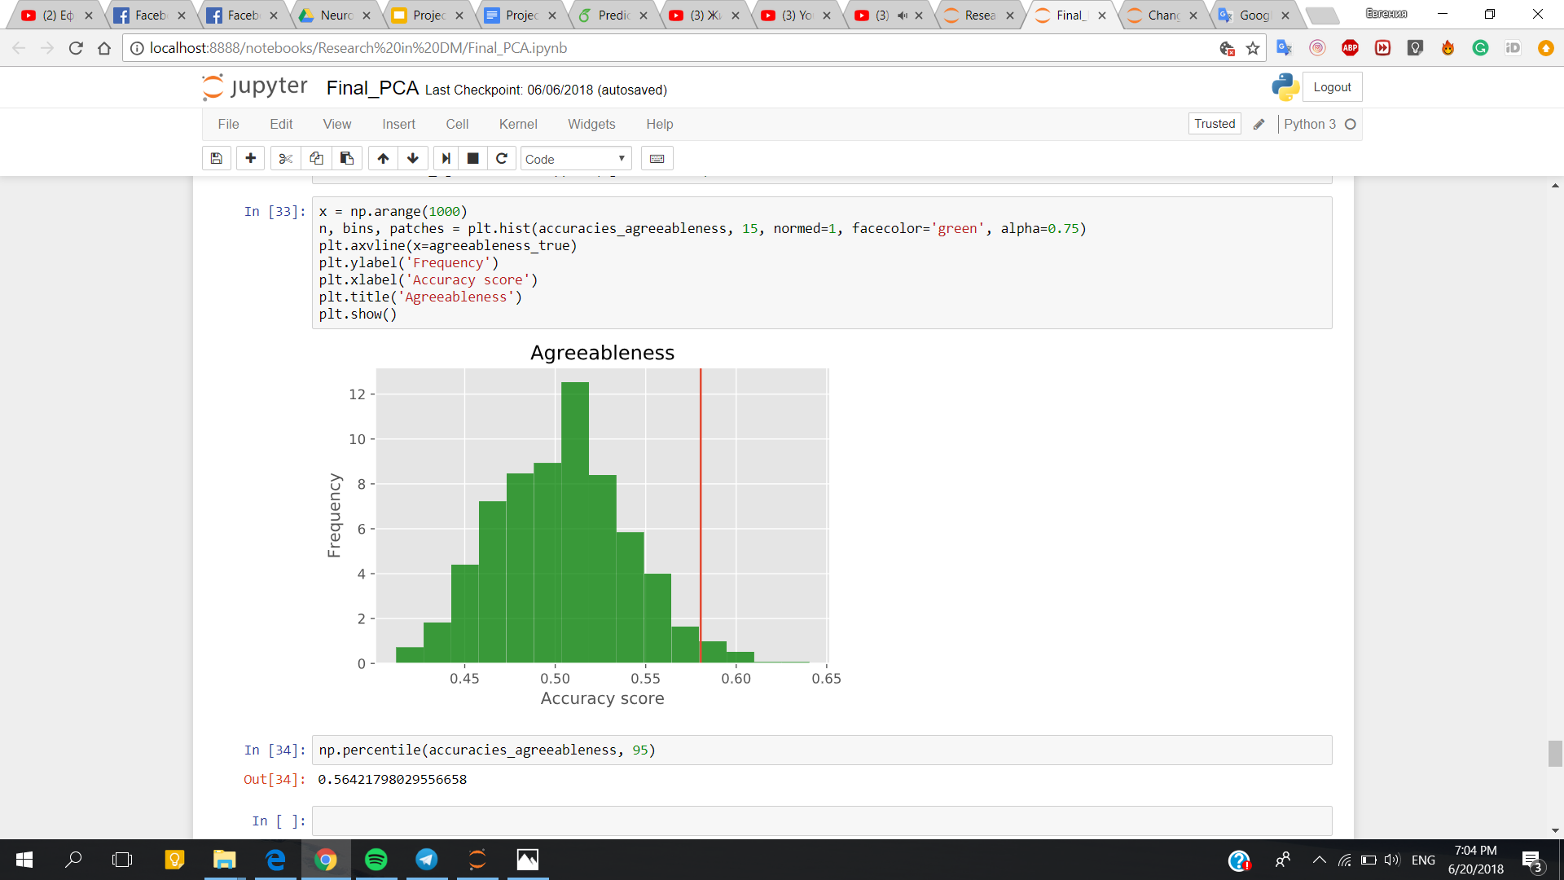

*Fig. 7. Hypothesis testing for a) Neuroticism trait b) Agreeableness trait*

To verify that the data could in fact be used to classify a feature accurately, we combined data from the eyes-open and eyes-closed dataset to get a dataset, where half of the subjects would have data from the eyes-open dataset and the other half would have data from the eyes-closed dataset. According to this, a label for a binary feature “eyes open” was added to the new dataset. On this dataset, we used the same binary classification methods as before, to see if we could accurately predict if the subjects’ eyes are open or closed and we obtained accuracy better than 80%. From this, we can conclude, that the methods we used, do work, if there’s a feature in the data that has a clear relationship with the rest of the data.

# **DISCUSSION**

In this project, we tried to find a way to predict personality traits from power spectra of EEG data from 289 subjects. As a result, we were not able to train a model that could make predictions accurately enough, where we could beyond a reasonable doubt say that the results are significant. Permutation tests for our best results gave p-values that were only around 0.05.

Previously published scientific literature has found some evidence or indication of the potential of there being a correlation between brain oscillations and a person’s personality. There have also been studies that claim otherwise.

Based on the results we found, we cannot claim there is a way to decode personality from EEG data, but then again, there seems to be at least some kind of connection there, otherwise we would have expected the results to be somewhat worse.

There are a couple of possible culprits here for our somewhat bad results: since the personality trait data was made binary beforehand (it was initially collected as continuous data), it could have made the data more inaccurate as a whole, since most people tend to fall somewhere around the middle with their personality trait scores. This could mean that a formidable group of people who would have been somewhere in the middle (and perhaps predicted to be as such), are now grouped together with the people that have very high or very low expressions of the traits and from the data standpoint, it could therefore be harder to make good predictions based on the power spectra data.

As always with datasets such as the one we used, we could say that if there was more data (more test subjects), it could have contributed for better models and thus better prediction accuracies.

One thing we know for sure, is that non-invasive EEG data tends to be very noisy, and it’s more than likely that this is also the case with the EEG data we used, which could also explain the difficulties for the classification methods to make good generalizations on the data.

In conclusion, we think that our results show at least some potential correlation in the EEG data and a person’s personality traits and that it could be worth it to study this matter further.

# **CONTRIBUTIONS OF EACH TEAM MEMBER**

*Yevheniia:* data preprocessing, analysis of averaged and aggregated data (PCE, t-SNE, binary classification), tuning model parameters, hypothesis testing, visualising obtained results.

*Janno:* data preprocessing, analysis of flattened data (PCE, t-SNE, binary classification), tuning model parameters, writing the report.

# **REFERENCES**

1. [Sang Eun Chi](https://www.sciencedirect.com/science/article/pii/S0191886905000735#!), [Chang Bum Park, Seung Lark Lim](https://www.sciencedirect.com/science/article/pii/S0191886905000735#!), [Eun Hye Park](https://www.sciencedirect.com/science/article/pii/S0191886905000735#!), [Young Hyurk Lee](https://www.sciencedirect.com/science/article/pii/S0191886905000735#!), [Kang Hee Lee](https://www.sciencedirect.com/science/article/pii/S0191886905000735#!), [Eun Joo Kim](https://www.sciencedirect.com/science/article/pii/S0191886905000735#!), [Hyun Taek Kim](https://www.sciencedirect.com/science/article/pii/S0191886905000735#!) 2005. *EEG and personality dimensions: A consideration based on the brain oscillatory systems.* Personality and Individual Differences 39, 3 (Feb. 2005), 669–681. https://doi.org/10.1016/j.paid.2005.02.017
2. [Kristjan Korjus](https://www.ncbi.nlm.nih.gov/pubmed/?term=Korjus%20K%5BAuthor%5D&cauthor=true&cauthor_uid=25762912), [Andero Uusberg](https://www.ncbi.nlm.nih.gov/pubmed/?term=Uusberg%20A%5BAuthor%5D&cauthor=true&cauthor_uid=25762912), [Helen Uusberg](https://www.ncbi.nlm.nih.gov/pubmed/?term=Uusberg%20H%5BAuthor%5D&cauthor=true&cauthor_uid=25762912), [Nele Kuldkepp](https://www.ncbi.nlm.nih.gov/pubmed/?term=Kuldkepp%20N%5BAuthor%5D&cauthor=true&cauthor_uid=25762912), [Kairi Kreegipuu](https://www.ncbi.nlm.nih.gov/pubmed/?term=Kreegipuu%20K%5BAuthor%5D&cauthor=true&cauthor_uid=25762912), [Jüri Allik](https://www.ncbi.nlm.nih.gov/pubmed/?term=Allik%20J%5BAuthor%5D&cauthor=true&cauthor_uid=25762912), [Raul Vicente](https://www.ncbi.nlm.nih.gov/pubmed/?term=Vicente%20R%5BAuthor%5D&cauthor=true&cauthor_uid=25762912), and [Jaan Aru](https://www.ncbi.nlm.nih.gov/pubmed/?term=Aru%20J%5BAuthor%5D&cauthor=true&cauthor_uid=25762912) 2015*. Personality cannot be predicted from the power of resting state EEG*. Front Human Neuroscience 9, 63 (Feb.2015), 669–681. https://doi.org/10.3389/ fnhum.2015.0006
3. Sheryl Ankrom. 2018. How Brain Cells Communicate With Each Other . Retrieved January 12, 2018 from: https://www.verywellmindcom/how-brain-cells-communicate- with-each-other-2584397
4. Karla Blocka. 2017. EEG (Electroencephalogram). Retrieved September 14, 2017 from https://www.healthline.com/health/eeg
5. Walter J. Freeman and Rodrigo Quian Quiroga. 2013. *Imaging Brain Function With EEG*. Springer, New York, Heidelberg, Dordrecht, London.
6. L.J.P.vander Maaten and G. E. Hinton. 2008. Visualizing High-Dimensional Data Using t-SNE. Journal of Machine Learning Research 9 (Nov.2008),2579–2605.
7. David Cournapeau. From 2007. Scikit-learn Machine Learning in Python. Retrieved October, 2017 from http://scikit-learn.org/stable/ index.html